W-12
YEAR 10 SCIENCE (GENERAL)
PHYSICAL SCIENCES
ASSIGNMENT - MOTION + NEWTON'S LAWS

NAME: MARK: 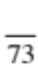

Apply relationships between force, mass and acceleration to predict changes in the motion of objects.

Mark | ND | NW | C | HC | O
Mark Range | 0-21 | 22-32 | 33-46 | 47-54 | 55-73

1. Perform the following conversions.

(a) 28.0 kmh⁻¹ = ms⁻¹ (b) 3.7 tonnes = kg

(c) 8.3 minutes = s (d) 2.70 cm = m
(4)

2. On the school oval, a person runs 50.0 m North, then 20.0 m West and then 30.0 m South. The total
time taken for the motion is 40.0 s.

(a) Draw a vector diagram to show the motion. Draw in the resultant vector (use a different
colour). (Use a scale of 1.0 cm = 10.0 m).

(3)

(b) Calculate the distance covered.

(2)
(c) Determine the displacement of the person by calculation.

(3)

(d) What is the average speed of the person?

(2)

(e) What is the average velocity?

(3)
3. A group of students investigated the movement of a toy car down an inclined plane in the laboratory,
and produced the following ticker-timer tape. The timer produces 50 dots per second.

. . . . . . . . . . . . . . . . . .

(a) Analyse the tape by calculating the velocity for every 5 dot-spacings. Record your values in the
table below.

Distance (m) | Time (s) | Velocity (ms⁻¹)
0.0 | 0.0 | 0.0

(3)

(b) Draw a velocity - time graph for these measurements.

(3)

(c) Use the graph to determine the acceleration of the toy. Show your working.

(3)
4. John decided to take a walk in the playground. He plotted the graph below to show how his distance
changed with time during the walk.

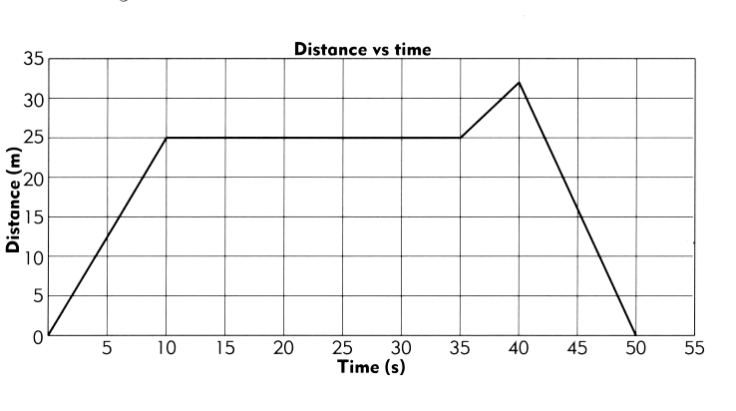
(a) At what time did John stop walking and talk with Brianna? (1)

(b) How many seconds did their conversation take? (1)

(c) Calculate John's speed during the first 10 s. Show your working.

(3)

(d) Calculate John's speed after he started moving again.

(3)

(e) What was John's total walking distance?

(2)
5. Calculate the gradient for each stage of the two displacement - time graphs below. Use your results to
construct the corresponding velocity - time graph for each, using the axes drawn below.

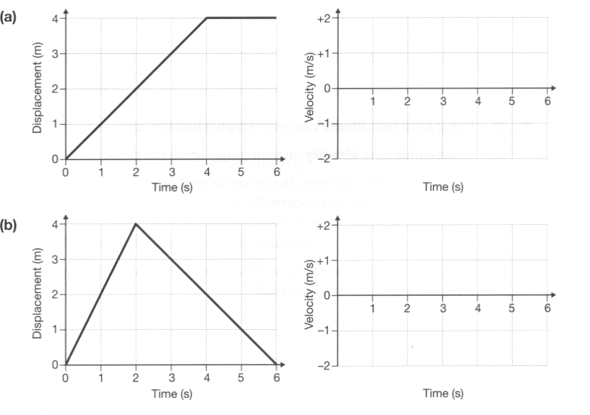
(4)
6. Sketch a graph for the following journey on the axes below.

Glenn had to deliver a parcel to Inga. He left home and drove 5 km to fill up with petrol.
It took him 10 minutes to reach the service station. Glenn stopped for 5 minutes to fill the
car with petrol. He continued on his journey away from his starting point to Inga's house,
and at a distance of 30 km he arrived. This part of the journey took another 15 minutes.
Glenn talked with Inga for 5 minutes before getting back into his car and returning home.
The trip back home took Glenn 20 minutes, during which time he did not stop.

(3)
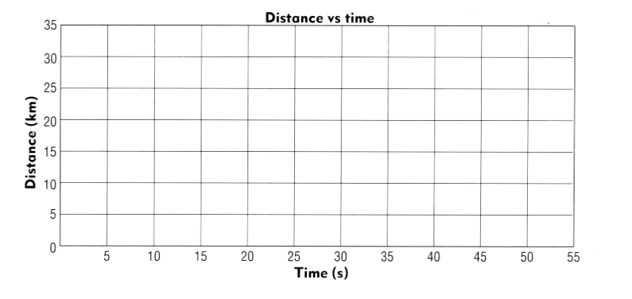

7. Complete the table below by calculating the missing values.

Force (N) | Mass (kg) | Acceleration (ms⁻²)
 | 10.0 | 2.0
 | 6.5 | 2.9
56.0 |  | 8.0
24.6 |  | 6.8
108 | 12.0
2.9 | 29.0

(6)

8. A car engine supplies 4.50 x 10³ N of force through the front wheels of a car and accelerates it
uniformly from rest. The mass of the car is 1.40 x 10³ kg.

(a) Calculate the acceleration of the car.

(3)

(b) Using your answer from part (a), calculate the velocity of the car after 5.0 s.

(3)

(c) Draw a velocity - time graph of the motion for 5.0 s and determine the displacement of the car.

(4)

9. A truck of mass 24.0 tonnes is moving at 80.0 kmh⁻¹ along Roe Highway when the driver notices a
small car that pulled out from a petrol station 60 m ahead. He hit the brakes sharply and just manages
to avoid hitting the back of the car. The truck ended up moving at 30.0 kmh⁻¹ and took 4.50 s to
achieve this.

(a) What is the deceleration of the truck?

(3)

(b) Calculate the average force exerted by the brakes of the truck.

(3)
10. Explain why you "lurch forward" when standing on a bus or train and the vehicle brakes suddenly.

(2)
11. Calculate the nett force and the acceleration for the following objects. Show your calculations.

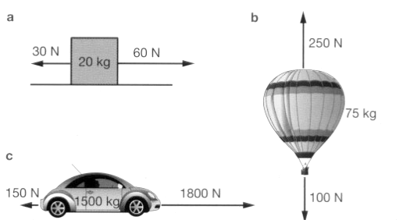

(6)

